**Assignment- 11**

Create a VPC security group for a private DB instance

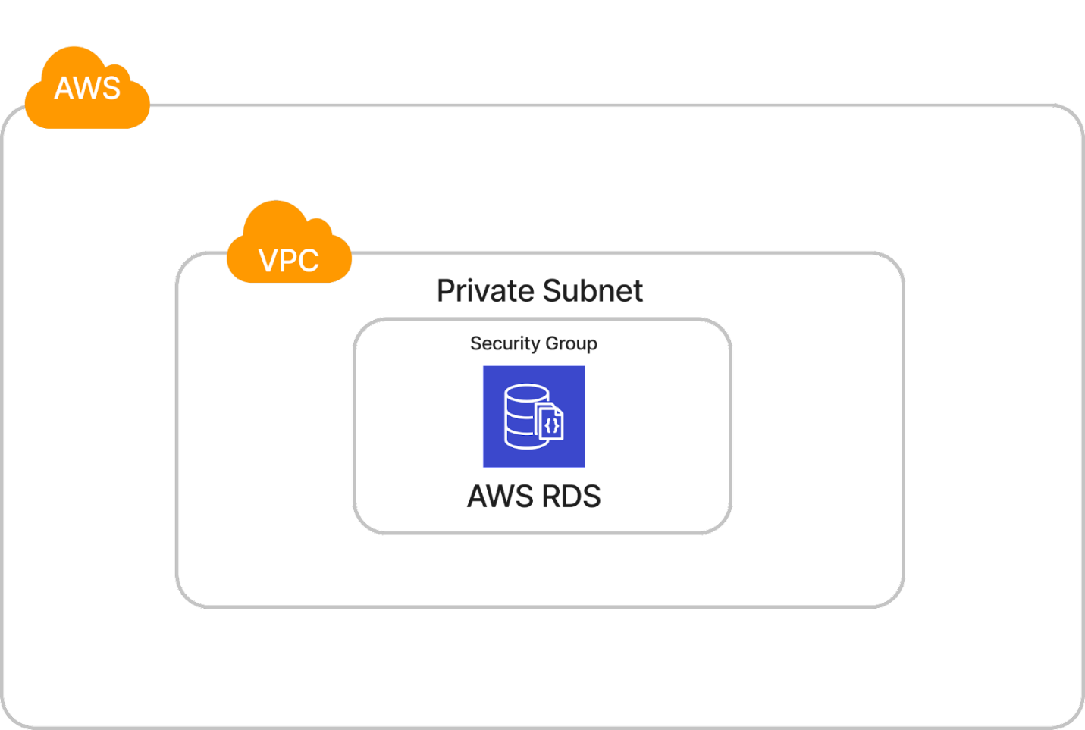

**ANS:**

1. **Created Custom VPC and Private Subnet in AZ** : us-east-1b

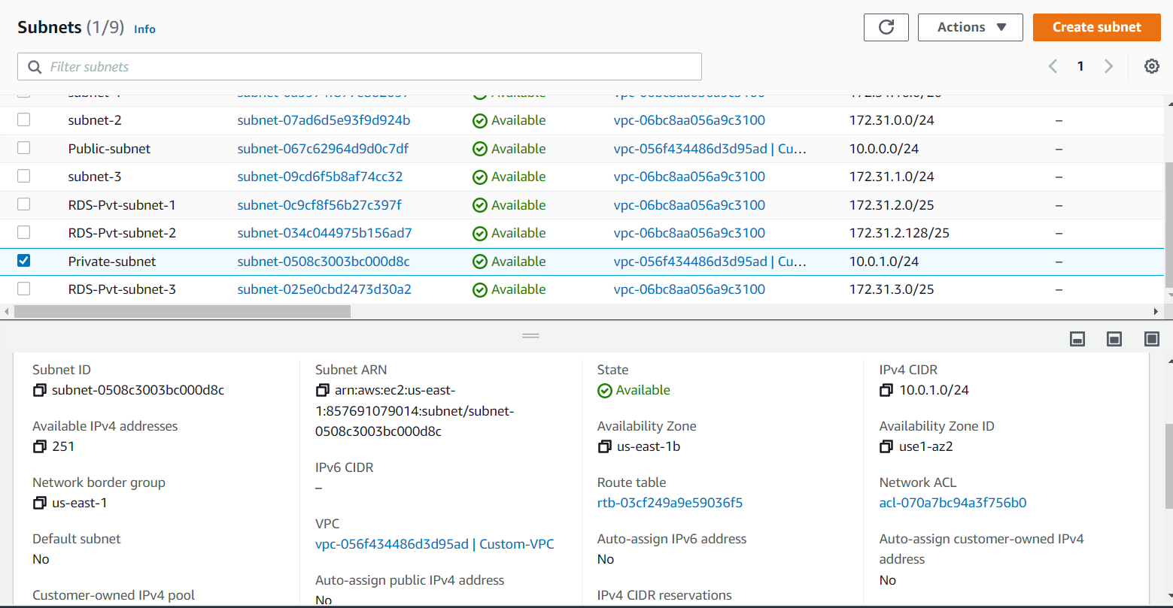

1. **Created AWS RDS database in Private Subnet with new Security Group.**

AZ: us-east-1b

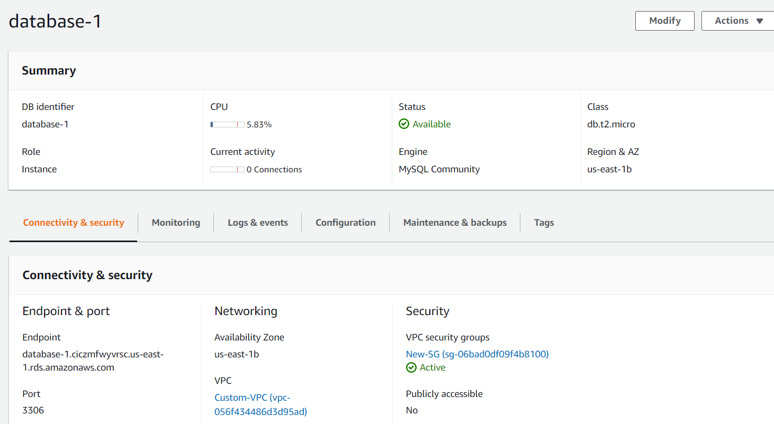

1. **Created New Security Group**.

